Dept. of Computer and Communication Engineering
Patuakhali Science and Technology University
^{7th} Semester (Level-4, Semester-II), Midterm Examination of B.Sc. Engg. (CSE), Janauary june: 2021
Course Code: CCE-416 Course Title: Network Routing and Switching Sessional
Credit Hour: 1.50 Full Marks: 15 Duration: 2 Hours
- Activity focuses on subnetting skills, basic device configurations and static routing. 15 marks
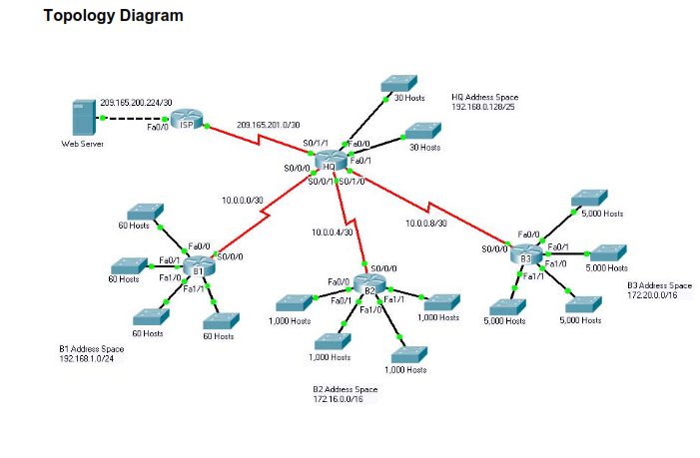
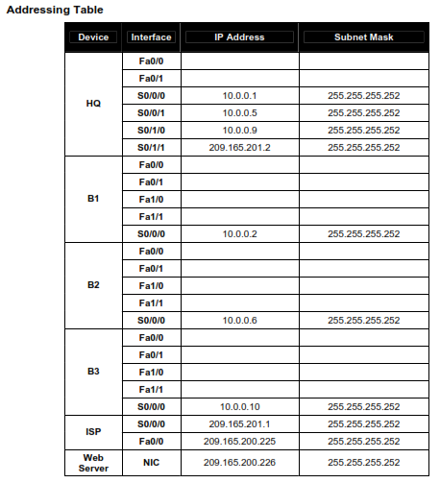
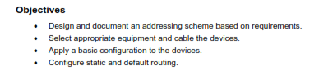
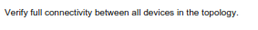
Configure Also a DHCP server

